Practical No. 4
Aim : ALP for signed multiplication of two 16-bit numbers
Name : Danish Altaf Solkar Class : CO - B
Enrolment no. : 24111590805 Batch : 2

Code :-
assume cs:code
assume ds:data
data segment
a DW 1234H
b DW -1000H
res DD ?
data ends
code segment
start:
MOV AX,data
MOV DS,AX
MOV AX,0000H
MOV AX,a
MOV BX,b
IMUL BX
LEA SI,res
MOV [SI],AL
MOV [SI+01],AH
MOV [SI+02],DL
MOV [SI+03],DH
INT 03H
code ends
end start

OUTPUT :-
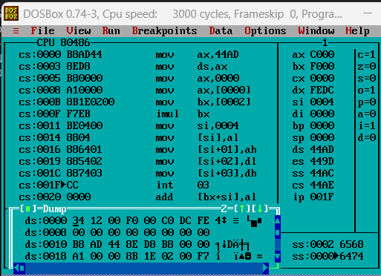

Process related  (15) | Product related  (10) | Total Marks  (25) | Signature

